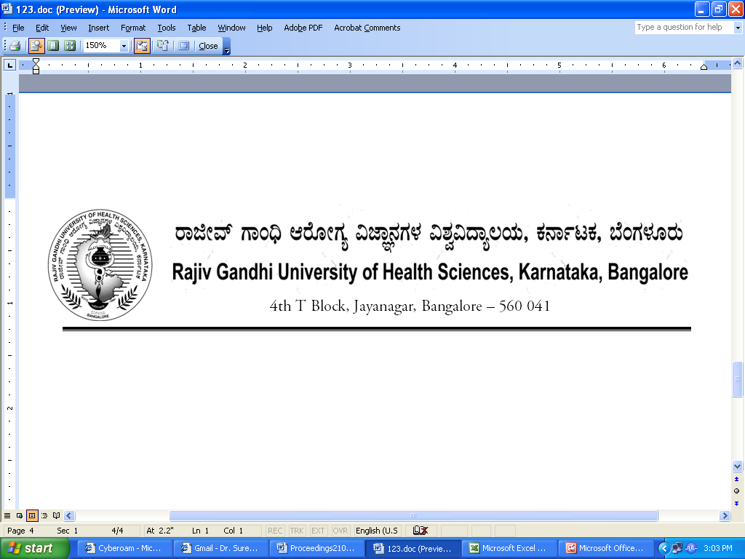

Dr.M.K. Ramesh Ph: 080-26961903, 26961946, Fax: 26961931
Registrar (Evaluation) Email: registrareva@rguhs.ac.in

Reg(E)Exam/UG/July-2018 Date: 26/04/2018

ADVANCE INFORMATION OF EXAM SCHEDULE

Sub: Conduct of University Under-Graduate Medical and Dental Theory Examinations during July 2018
**********

The provisional dates for the following University Theory Examinations will commence as notified below.

Faculties | Provisional Date
Medical and Dental | 3rd July, 2018
MBBS I Phase Supplementary Examination | 22nd September, 2018

The Principals of the concerned colleges affiliated to the University are requested to notify the same on the Notice Board of their colleges for information to the students concerned and circulate the same to all the Staff / Department of your college for information and follow up.
Sd/-
Dr. M.K. Ramesh
Registrar (Evaluation)

To:
All the Principals of Medical and Dental Colleges affiliated to RGUHS for information and needful action.

Copy to:

- PA to Vice-Chancellor/PA to Registrar/PA to Registrar (Evaluation)/Finance Officer,
RGUHS, Bangalore.
- Deputy Registrar (Admn) / Dy. Registrar Computer Section (Eval) RGUHS, Bangalore.
- Asst. Registrar, Regional Center, Belgaum / Gulbarga.
- Guard File.

